Student worksheet

3.1 Scientists refine models and theories over time

Pages 66–69

The history of the periodic table

1 Who is usually credited as the creator of the modern periodic table?

|  |
| --- |
|  |

2 Why were there gaps in the periodic table?

|  |
| --- |
|  |

3 Create a timeline that demonstrates the development of the periodic table. You must show the name of the scientist, the year that they made their discovery or idea, and the details of their discovery or idea.

|  |  |  |
| --- | --- | --- |
| Scientist | Year | Discovery |
|  |  |  |
|  |  |  |
|  |  |  |
|  |  |  |
|  |  |  |
|  |  |  |
|  |  |  |
|  |  |  |
|  |  |  |
|  |  |  |
|  |  |  |

4 Match each famous scientist with their contribution to the development of the periodic table.

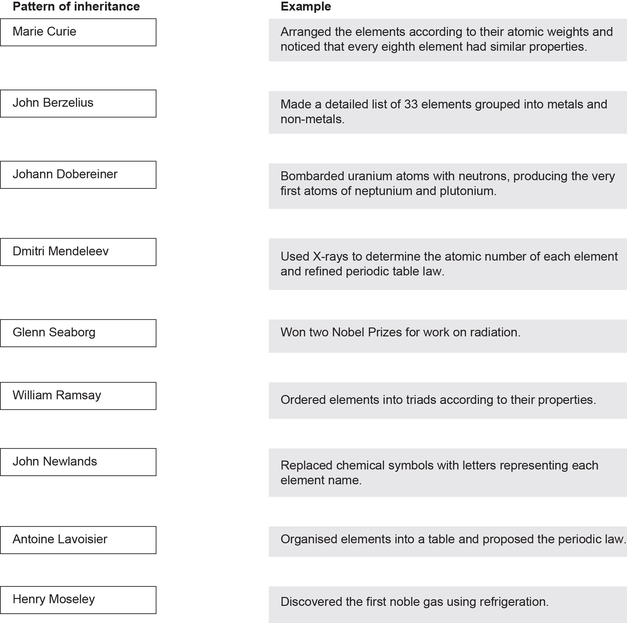

Extend your understanding

5 Research to determine who discovered the following elements, when they were discovered, and how the person made their discovery.

a Cobalt

|  |
| --- |
|  |
|  |
|  |
|  |

b Hydrogen

|  |
| --- |
|  |
|  |
|  |
|  |

c Nitrogen

|  |
| --- |
|  |
|  |
|  |
|  |

d Helium

|  |
| --- |
|  |
|  |
|  |
|  |

Student worksheet

3.2 The structure of an atom determines its properties

Pages 70–73

Atomic structure

1 Complete the following table.

|  |  |  |  |
| --- | --- | --- | --- |
| Sub-atomic particle | Mass | Charge | Location in an atom |
| Proton |  |  |  |
| Neutron |  |  |  |
| Electron |  |  |  |

2 What determines the atomic number of an atom?

|  |
| --- |
|  |

3 Why is the atomic number used to order the elements on the periodic table?

|  |
| --- |
|  |
|  |
|  |

4 What determines the relative atomic mass?

|  |
| --- |
|  |
|  |

5 How are electrons arranged in an atom?

|  |
| --- |
|  |

6 What is the outer-most electron shell called?

|  |
| --- |
|  |

7 What determines the properties of elements?

|  |
| --- |
|  |
|  |

8 On the periodic table, what is a horizontal row called?

|  |
| --- |
|  |

9 On the periodic table, what is a vertical column called?

|  |
| --- |
|  |

10 For the element fluorine, explain how to use the information in periodic table to calculate



a the number of protons

|  |
| --- |
|  |
|  |

b the number of neutrons

|  |
| --- |
|  |
|  |

c the number of electrons

|  |
| --- |
|  |
|  |

11 In the Bohr model of electron configuration, what is the maximum number of electrons that can be in the following shells? (Show a formula and calculations for each answer.)

a first shell

|  |
| --- |
|  |
|  |

b second shell

|  |
| --- |
|  |
|  |

c third shell

|  |
| --- |
|  |
|  |

d fourth shell

|  |
| --- |
|  |
|  |

12 Draw the electron configuration for the following elements.

|  |  |  |  |
| --- | --- | --- | --- |
| Nitrogen | Oxygen | Fluorine | Neon |
| Phosphorus | Silicon | Chlorine | Argon |

13 Explain the trend in electron shell configuration

a across a period.

|  |
| --- |
|  |

b down a group.

|  |
| --- |
|  |

Extend your understanding

14 Draw the proposed electron configurations for both of the following atoms using the given configurations.

|  |  |  |
| --- | --- | --- |
| Potassium:  19 electrons | 2,8,8,1 | 2,8,9 |
| Calcium:  20 electrons | 2,8,10 | 2,8,8 2 |

15 Identify which of the electron configurations in the previous question are correct and explain your answer.

|  |
| --- |
|  |
|  |
|  |
|  |
|  |
|  |

16 Using the knowledge you have gained from this concept, draw the electron configurations of bromide and tin.

|  |  |
| --- | --- |
| Bromine | Tin |

Student worksheet

3.3 Groups in the periodic table have properties in common

Pages 74–75

Trends of metals in the periodic table

1 Name five properties that all metals have in common.

|  |
| --- |
|  |
|  |
|  |
|  |
|  |

2 For the three metal groups in the periodic table, complete the following table.

|  |  |  |  |
| --- | --- | --- | --- |
| Name |  |  |  |
| Group number |  |  |  |
| Valence electrons |  |  |  |
| Properties |  |  |  |

Extend your understanding

3 Research the structure of metals. For each of the five properties of metals, draw a diagram showing the metal particles that demonstrates how the property occurs. For each diagram, explain what happens to the particles for this property to occur.

|  |  |
| --- | --- |
| Diagram | Explanation |
|  |  |
|  |  |
|  |  |
|  |  |
|  |  |

Student worksheet

3.4 Non-metals have properties in common

Pages 76–77

Trends of non-metals in the periodic table

1 Name six properties of non-metals.

|  |
| --- |
|  |
|  |
|  |
|  |
|  |
|  |

2 Which groups of the periodic table are non-metals found in?

|  |
| --- |
|  |

3 How many elements of the periodic table are non-metals?

|  |
| --- |
|  |

4 Where would you find non-metals on Earth?

|  |
| --- |
|  |
|  |

5 Which groups are made entirely of non-metals, what are the names of these groups?

|  |
| --- |
|  |
|  |

6 Where are metalloids found in the periodic table?

|  |
| --- |
|  |
|  |

7 Why are some metalloids considered to be semiconductors?

|  |
| --- |
|  |
|  |

8 For the two non-metal groups in the periodic table, complete the following table.

|  |  |  |
| --- | --- | --- |
| Name |  |  |
| Group number |  |  |
| Valence electrons |  |  |
| Properties |  |  |

Extend your understanding

9 Research the structure of metals and non-metals to explain why

a non-metals do not conduct electricity.

|  |
| --- |
|  |
|  |

b non-metals are not shiny.

|  |
| --- |
|  |
|  |
|  |

c non-metals do not conduct heat well.

|  |
| --- |
|  |
|  |
|  |
|  |

Student worksheet

3.5 Metal cations and non-metal anions combine to form ionic compounds

Pages 78–79

Ionic compounds

1 What is the difference between an atom and an ion?

|  |
| --- |
|  |
|  |
|  |

2 What name is given to a metal when it forms an ion, and what type of charge does it have?

|  |
| --- |
|  |

3 What name is given to a non-metal when it forms an ion, and what type of charge does it have?

|  |
| --- |
|  |

4 What is an ionic bond?

|  |
| --- |
|  |
|  |

5 An ionic bond is between which two types of elements?

|  |
| --- |
|  |

6 Explain what happens to an ionic compound when it is struck with a hammer. Include diagrams in your explanation.

|  |  |  |
| --- | --- | --- |
| Before being struck: | After being struck: | |
|  | | |
|  | | |
|  | | |
|  | | |

7 Complete the following table to demonstrate the number of electrons gained or lost by atoms to form ions.

|  |  |  |
| --- | --- | --- |
| Group number | Number of valence electrons | Number of electrons gained or lost |
| 1 |  |  |
| 2 |  |  |
| 13 |  |  |
| 15 |  |  |
| 16 |  |  |
| 17 |  |  |
| 18 |  |  |

8 Draw the electron configuration of lithium and fluorine, and then redraw these configurations to demonstrate how an electron is donated between the atoms.

|  |
| --- |
|  |

9 Other than being brittle, what is the other main property of ionic compounds? Explain this property.

|  |
| --- |
|  |
|  |

10 What is a polyatomic ion? Give an example.

|  |
| --- |
|  |
|  |

Extend your understanding

11 Access a valency table (your teacher may have one or you can search for one on the internet). Use the valency table to determine the formulas of the follow ionic compounds.

a Sodium chloride

|  |
| --- |
|  |

b Sodium nitrate

|  |
| --- |
|  |

c Potassium nitrate

|  |
| --- |
|  |

d Calcium hydroxide

|  |
| --- |
|  |

e Aluminium oxide

|  |
| --- |
|  |

f Hydrogen phosphate

|  |
| --- |
|  |

g Sodium Hydrogen carbonate

|  |
| --- |
|  |

h Ammonium hydroxide

|  |
| --- |
|  |

i Sodium sulfate

|  |
| --- |
|  |

j Calcium sulfate

|  |
| --- |
|  |

Student worksheet

3.6 Non-metals combine to form covalent compounds

Pages 80–81

Covalent bonding

1 Between which types of atoms does covalent bonding occur?

|  |
| --- |
|  |

2 What do these atoms do when they covalently bond?

|  |
| --- |
|  |
|  |

3 Draw the covalent bonding in the following molecules.

|  |  |
| --- | --- |
| Ammonia (NH3) | Methane (CH4) |
| Hydrofluoric acid (HF) | Carbon tetrachloride (CCl4) |
| Carbon dioxide (CO2) | Phosphorous trifluoride (PF3) |

4 What is a diatomic molecule? Give an example.

|  |
| --- |
|  |
|  |
|  |

5 What is the difference between an atom and a molecule? Give an example.

|  |
| --- |
|  |
|  |
|  |

6 Where do electrons reside in covalent bonding?

|  |
| --- |
|  |

7 Why are covalent bonds so strong?

|  |
| --- |
|  |
|  |
|  |

Extend your understanding

8 Suggest the most likely chemical formula between the following atoms and draw their covalent bonding.

|  |  |  |
| --- | --- | --- |
| Atoms | Chemical formula | Diagram |
| Carbon and fluorine |  |  |
| Silicon and oxygen |  |  |
| Hydrogen and chlorine |  |  |
| Phosphorous and chlorine |  |  |
| Carbon and sulfur |  |  |

Student worksheet

3.7 Metals form unique bonds

Pages 82–83

Metallic bonding

1 What are three of the structural properties that metals have in common?

|  |
| --- |
|  |
|  |
|  |

2 Where do delocalised electrons come from?

|  |
| --- |
|  |

3 Why are they referred to as ‘delocalised’?

|  |
| --- |
|  |
|  |

4 Why are metals able to conduct electricity?

|  |
| --- |
|  |
|  |

5 What is the relationship between temperature and conductivity in metals?

|  |
| --- |
|  |
|  |

6 Why are metals shiny?

|  |
| --- |
|  |

7 What is an alloy?

|  |
| --- |
|  |

8 What are the benefits of using alloys?

|  |
| --- |
|  |

9 What is a smart alloy?

|  |
| --- |
|  |
|  |
|  |

10 How are the properties of smart alloys beneficial to society?

|  |
| --- |
|  |
|  |
|  |

11 Explain one use of a smart alloy.

|  |
| --- |
|  |
|  |
|  |

Extend your understanding

12 An essential tool in chemistry is the process of electrolysis. Conduct some research and answer the following questions:

a What is electrolysis?

|  |
| --- |
|  |
|  |
|  |

b Which scientist paved the way for electrolysis in modern chemistry?

|  |
| --- |
|  |

c In electrolysis, what does ‘reduction’ mean?

|  |
| --- |
|  |
|  |
|  |

d In electrolysis, what does ‘oxidation’ mean?

|  |
| --- |
|  |
|  |
|  |

e A transformation of energy occurs in electrolysis. What is this transformation?

|  |
| --- |
|  |

f Why is electrolysis essential to modern society? Name two applications of this process.

|  |
| --- |
|  |
|  |
|  |
|  |

Student worksheet

3.8 Nanotechnology involves the specific arrangement of atoms

Pages 84–85

Nanotechnology

1 What is the diameter of the average atom?

|  |
| --- |
|  |

2 Why is this an average diameter, and not the diameter of every atom?

|  |
| --- |
|  |
|  |

3 Do you think that this average would more accurately represent the size of a hydrogen, a barium or an ununoctium atom? Explain your answer.

|  |
| --- |
|  |
|  |
|  |

4 What is nanotechnology?

|  |
| --- |
|  |
|  |
|  |

5 What scale does nanotechnology use?

|  |
| --- |
|  |

6 Give an example of nanotechnology and how it could be used.

|  |
| --- |
|  |
|  |
|  |

7 How could nanobots be beneficial to the field of medicine?

|  |
| --- |
|  |
|  |
|  |
|  |

8 What are the similarities in properties between metals and carbon nanotubes?

|  |
| --- |
|  |
|  |
|  |

9 What are the differences in properties between metals and carbon nanotubes?

|  |
| --- |
|  |
|  |
|  |

10 Choose two possible applications of nanotubes and explain how they may be of benefit.

|  |
| --- |
|  |
|  |
|  |
|  |
|  |
|  |

Extend your understanding

11 The buckyball is another example of nanotechnology developed by chemists. Conduct some research and answer the following questions.

a What is the scientific name of a buckyball?

|  |
| --- |
|  |

b What is a buckyball?

|  |
| --- |
|  |
|  |
|  |

c What is the application of a buckyball?

|  |
| --- |
|  |
|  |

d From your answer to the previous question, explain why you think the buckyball was first synthesised.

|  |
| --- |
|  |
|  |
|  |
|  |